IFSM300 LEO content
Week 1 – Introduction
The following should be completed in Week 1:
Read:
Overview (at top of list on the left side of your screen)
Review the Course Schedule (module listed on left side of your screen)
Syllabus (module listed on left side of your screen)
Read/View all Week 1 Content
Do:
Introduce yourself in the Introductions Discussion
Practice with the Competitive Advantage Learning Activity
Complete Week 1 Discussion = Post and reply to two student posts
Complete Week 1 Quiz
Textbook: This class uses an ebook, available through Open Textbook Challenge and posted in Course Resources; individual chapters are posted each week as they are assigned and may be downloaded.

Content

This week, you will learn how businesses develop their strategies for achieving competitive advantage and how information systems can be used for competitive advantage. In the Week 1 Learning Resources below, there are a number of resources provided to help you understand this week's concepts and to prepare you to complete the first assignment, which will be due next week. After reading the Business Perspective Course Module and Chapters 1 and 7 in the e-textbook, you will then read about business strategy and strategic planning. You will want to come back to these resources when you being work on the Stage 1 assignment. Be sure to scroll down to see all the Learning Resources for this week.
The following table lists the Week 1 outcomes, mapped to the corresponding course outcome. The course outcome gives you "the big picture," and the weekly outcomes provide more detailed information that will help you achieve the course outcome.
Course Outcome Met in Week 1 | Week 1 Outcomes
- analyze business strategy to recognize how technology solutions enable strategic outcomes | - describe business strategy  - describe the components of competitive advantage  - describe how information systems can provide businesses with competitive advantage  - define what an information system is by identifying its major components

Week 1 Learning Resources

Overview
This module is designed to give you a basic understanding of organizations—their structure as well as the financial and competitive aspects that provide the basis for all information systems justification and use.

Objectives
After completing this module, you should be able to:
- explain the key factors that differentiate business models—how businesses monitor performance
- apply the competitive forces model and the value chain model
- demonstrate an understanding of the different systems strategies used in businesses today
Introduction
The Organizational Model
The Competitive Forces Model
Financial Performance Analysis
The Value Chain Concept

Information systems in organizations is the study of the integration of two major areas of study: business and systems. Business, for our purposes in this course, includes organizations that are for profit, not for profit, and governments, and they can be of any size or shape. We will deal with formal organizations as opposed to ad hoc organizations, which are temporary in nature and have a limited scope and objective.
Before we begin our analysis of the specifics of these businesses, it is important that we understand that all of us, including the businesses that we will discuss, are part of the world we live in, and that affects our lives and the strategies of all businesses. Jim Carroll, a futurist, did a webcast for SAP (Systems Applications and Products), a major software supplier, in which he defines the current world environment and how it affects people and business and the resulting systems activity. It will place this course and module in proper perspective. We will watch the first part of the webcast, which is approximately 14 minutes long, but very interesting and enjoyable.
View SAP's Jim Carroll webcast before continuing, or you may read a transcript. (Note: The transcript is from a different version of Carroll's presentation, but it addresses the same concepts.)
--video
The two major areas of business that we will focus on are people and organization, although all aspects of business will be involved. People include those employed at the business as well as people outside—customers, suppliers, contractors (those who are directly involved in the business), and others who are indirectly involved in the business and whose actions or activities can affect the business. It is important to note that "65% of children in preschool will be employed in roles and jobs that don't exist today [Australia's Innovation Council chairman]" (Carroll, 2007). The organization is the physical structure of the business and how systems and people integrate into that organization. Systems are business processes and computer systems used in the business.
The factors discussed in this module will help you understand and define the systems needed to support any business. Focusing on a company's systems without first understanding its business model, the fundamentals of its business type(manufacturing, construction, finance, distribution, service, government, and so on), and its strategy can lead a person to formulate technology "solutions" that ineffectively support the business and its objectives. Information systems are only tools that are used to support a business; therefore, if the tools are not aligned with business requirements, resources (time, money, and people) may be wasted, triggering an undesirable outcome.
To begin, you must understand the factors that help define the many different business models you may encounter and how these factors may influence your organization and its systems needs. To help you with this, we will describe and explain an organization model.
Once you understand the organization model, you must also learn to recognize the competitive forces that influence business strategy and, therefore, systems strategy. Rapid changes in both technology and the business environment are having more and more influence on business strategy. Later in this module, we will examine a competitive forces model that will clarify many of these considerations.
The next area that we will study is the "scorecard" that organizations use to determine if they are winning or losing in comparison with their objectives and their competition. Regardless of an organization's objective or type, the score is kept in terms of money; therefore, it is crucial to understand how these scorecards are calculated—financial performance analysis. We will also examine nonprofits and governments. Although these organizations do not strive to make a profit, they must nevertheless maintain scorecards to ensure that they have sufficient financial resources to achieve their objectives and guarantee their survival and growth.
We will end this module with a discussion of the value chain concept, which highlights specific business activities in which competitive strategies can best be applied (Laudon & Laudon, 2006) and in which information systems are most likely to have a specific benefit, or value added.

Introduction
In order to develop excellent systems that support an organization, one must understand the variables that affect an organization and their relative value or importance. In section II of module 1, we present the organization model that will help you understand the many variables that impact an organization. This model should provide the basis for understanding the organization, which is crucial to any systems development activities.
An individual who is considering starting a business must write a business plan that describes the many variables that will affect the business and must be considered in detail and documented. The plan serves a number of purposes:
- To ensure that the entrepreneur understands all of the variables that can affect the business, as well as the specifics of each variable, such as "Who are the competitors?"
- Provide the details of the business when communicating to others for advice, financing, or support of the business. These details demonstrate that the entrepreneur understands the interrelationships between expenses and revenue.
- Provide a tool to monitor the business's progress in accordance with the plan so that adjustments can be made based on actual performance.
The importance of the various variables is not the same for all businesses, but their actual importance to the specific business, and strategies to deal with them, must be documented and explained in the business plan. Understanding the organization model serves the same purposes in systems development. It is important to understand these factors to ensure that information systems effectively support the business plan.
The organization model presented below is a general graphical representation of a business with all of the variables that can affect a business. Since all of the variables will affect all businesses to varying degrees, the crucial role of the model is to identify their importance and help the business develop a strategy for dealing with each set of important variables. To graphically identify the importance and relationship to the organization, the thickness of the connecting arrow is used. The direction that the arrow is pointing indicates whether the variable impacts the organization, or if the organization can affect the variable, or both. A good example might be competition. The actions or size of the competition can affect the organization, while the strategy used by the organization could affect the competitors and force them to make changes.
Some of the indirect uncontrollable variables do not have arrows because their specific impact is difficult to identify at a point in time until changes occur, but they can have huge effects on the organization. For instance, Congress recently passed an energy bill that outlaws incandescent light bulbs in 5 to 10 years. This will have a huge impact on the light bulb manufacturers that could not be anticipated by the organizations. Another example would be the impact of a requirement for ethanol to be 80 percent or more of auto gasoline. Two years ago, chicken farmers could not have forecast the shortage of corn for livestock feed, which results in price increases for milk and eggs. The particular indirect variables are known, but the exact impact is unknown. In some instances, organizations can impact the indirect variables. For example, the auto industry successfully lobbies against higher mileage requirements for sport utility vehicles and trucks, resulting in less severe changes than planned.
IT applications are designed to help a business decrease the costs of processes and manage crucial aspects of a business, which means that they should be used to support the most important variables, and help decrease the related costs. When analyzing case studies or a particular organization, students may not recognize the importance of focusing on the most significant variables. For instance, students were presented with a case study about Albertsons, a supermarket chain that invested heavily in technology creating customer self check-outs to eliminate cashiers, as well as handheld computers that could be used in conjunction with the creation of shopping lists online that would lead customers to those items in the store. Students didn't identify the need to focus the systems effort on inventory control and logistics, although these are the two largest costs and the most important variables in the grocery business.
In the supermarket business, eliminating a cashier who earns $10 an hour has very little impact on the overall efficiency of the business, and leading shoppers along a preset path minimizes impulse buying, which is a major source of revenue to the store. Students saw these systems efforts as great investments because of the innovative use of technology, not recognizing that these variables were not crucial to Albertsons's operations. This organization lost a great deal of money, and in 2006, it was bought out. The new management is focusing on the correct areas.
The organizational model described below is designed to make you sensitive to what areas can affect a business, as well as their importance to a business. The business strategy and the crucial variables identified in the model provide a guide to understanding the organization. Understanding an organization is necessary before any systems projects are commissioned, because that understanding ensures that the IT efforts are focused correctly to maximize the benefits to the organization.
Many variables affect organizations. An organization can control some variables, but not others. Before we can understand the many variables that affect a business, we must have some common terminology.
The following are the direct, controllable variables in the business environment that define a business model. Hold your mouse over each term to see its definition and examples of it.
business environment
competition
customers
employees
location
objective
owners
special organizational components
suppliers
The following are indirect, uncontrollable variables that help define the environment in which a business must function. Hold your mouse over each term to see its definition and examples of it.
government regulation
environmental factors
politics
laws
ethics
time
risk
The direct and indirect variables create the significant differences between business models.
There are three basic business models used today:
- the profit model
- the nonprofit model
- the government model
All of these models have the same basic elements: assets, employees, revenue, and expenses. However, their organization and the relative importance of the above variables in meeting business objectives have an unlimited number of variations. These variations in business models are far greater between industries than between companies within an industry.
These differences in business models are the determinants of the organizational structure, technical infrastructure, business systems, and computer systems needed to support their individual objectives. You must, therefore, know both the business model and the business strategy if you are to understand, develop, or modify a business's systems strategy.

A. Business Model
To better understand the business model concept, let's look at a well-known company: Walmart.
Because Walmart, Kmart, Target, Costco, Nordstrom, and Sears are part of the retail industry, their organization and business models are similar. Later, we will discuss how these very similar companies differ in their business strategies and, therefore, in their systems design and use.

1. Walmart
Walmart's business objective is to make a profit (the result of subtracting expenses from revenue) by selling many different items and services that it purchases from suppliers at the lowest possible price. An early Walmart mission statement was "To give ordinary folk the chance to buy the same thing as rich people" (Walmart, 2006a). It achieves this by having the lowest possible expenses. Walmart is a publicly held company, which means that it has issued stock (shares of the company or partial ownership) to finance the business; therefore, Walmart's owners are its stockholders, who are the beneficiaries of its profits.
Walmart's customers are the people who enter its stores or visit its website with the intent of purchasing merchandise or services that are located both within the United States and also in many foreign countries. The company has thousands of employees who perform many different jobs and may be members of a special organizational component, such as a subsidiary or even a fast-food or optical franchise. Walmart's many competitors, such as Target, Kmart, and Home Depot, influence its business strategy.
In addition to the controllable variables, Walmart must function successfully while all of the indirect, uncontrollable variables mentioned above are affecting it. Therefore, Walmart's business strategy must address these variables and monitor their ongoing impact on controllable variables so the company can make changes in its business strategy or address potential changes with its agencies before implementation.
Let us first look at a general business model, shown in figure 1.1, and then see how it would look for Walmart.
Figure 1.1
General Business Model
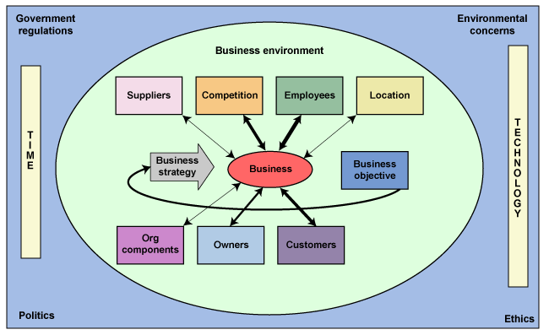
The above diagram shows all of the direct and indirect variables, the business strategy, and the business objective. You will note that the business strategy is an arrow driving the business toward its objective. The objective has an arrow going back to the business strategy, implying that the business objective can change because of forces acting on the business from the environment or indirect variables, which may necessitate a change in the business strategy.
In the diagram, all of the direct variables are connected to the business by two-headed arrows, indicating that each variable affects the business and the business can affect the variables. Ordinarily, the width of an arrow would indicate the degree to which the variable can affect the business or be affected by the business. Because there is a constant stream of feedback from business objectives (profitable operations) back to business strategy, these linkages may vary in width over time, based on the current degree of impact. Although the general model above shows all of the direct-variable arrows as being the same width, that is extremely unlikely in reality.
The blue area outside the business environment represents those factors that can influence the business but that the business cannot control—government regulations and environmental, political, and ethical concerns. It is safe to say that all businesses exist in this same area, regardless of their industry, and that these factors can affect them.
Let's look at the model for Walmart, as shown in figure 1.2, below.
Figure 1.2
Walmart Business Model
Walmart is in the retail industry, and its business is selling merchandise and services. It has many customers and suppliers, which are the major forces that affect its type of business. Although the cost of its merchandise depends far more on its suppliers and locations than on its employees, Walmart does have a great many employees. When Walmart's customers walk into one of its stores, they have an expectation that the retailer must meet, or the customer will have an unsatisfactory experience. Clearly, that expectation at Walmart is low prices; customers at other retailers may have different expectations. For example, at an upscale store, customers may expect exceptional quality and customer service in exchange for paying premium prices.
The supplier arrow is the widest of all of the arrows, which means that Walmart's suppliers have the biggest effect on its business and therefore should be of greatest concern to the company. Moreover, because Walmart recognizes this influence, the company negotiates with its suppliers for the best prices and product delivery based on expected sales. The competition arrow is quite narrow, indicating that although there are competitors, they are not a serious concern at this time.
Although employees account for a portion of Walmart's operating expenses, they are an insignificant expense when compared with the impact of suppliers. As the largest private-sector employer in the United States, employee-information maintenance and payroll are significant activities. Because Walmart has thousands of locations in the United States and around the world, it must adhere to many national payroll requirements that add complexity and affect its business. Based on the company's financial structure, however, employees have less impact on its total expenses than other areas do.
Walmart's owners are stockholders, but because they lack organization and strength, their impact is not as great as that of other players in the Walmart model. The stockholders' strength is minimized because the stock is widely distributed, not concentrated. If individual investors have problems with the company's management, they can do little but sell their stock. As a public corporation, however, Walmart does have the responsibility of making regular reports, not only to their stockholders but also to the Securities and Exchange Commission.
Most of the company's organizational components are the stores and the regions in which the stores are located. Although there are some franchises involved in food concessions and optical services in the stores, Walmart has no network of distributors or specialty stores with which to contend.
The time in which Walmart exists is favorable for its business because the dispersion of people and their mobility allow the company to have a large customer base over a significant geographic area. Its strategy of providing "everyday low prices" makes its customers feel that traveling to a Walmart store to capture savings is a wise decision.
Technology affects Walmart's business in two main ways, both of which help it support its business strategy. The first is simply that technological innovation in the areas of the merchandise it sells helps to keep customers coming to the stores, increasing sales. "Things are changing so fast with some stuff that obsolescence happens in six months …" (Carroll, 2007). For example, the latest iPod or video game provides new merchandise opportunities regularly. Second, the improvement of systems and technology that support logistics helps Walmart lower its costs. The Internet enables it to enlarge its customer base and assists with sales growth, even in locations in which Walmart has no stores.
Politics affects the Walmart business model, as we can see in Maryland when politicians try to pass a law that would apply only to Walmart, requiring the company to either maintain a certain level of medical insurance for all of its employees or pay the state for employee medical coverage. Ethics and politics may be interacting when we hear that child labor in underdeveloped countries manufactures the products it sells. The ethical treatment of employees is also an issue for Walmart, not necessarily because of how it treats its people, but because of its size and visibility.
As a retailer, Walmart's concerns with environmental issues are relatively insignificant and are limited mostly to energy usage and recycling, as opposed to a manufacturing company, for which these issues would be much more important. Walmart's website does indicate a corporate goal of "doubling the fuel efficiency of our trucks, becoming 100% supplied by renewable energy, and creating zero waste in our stores" (Walmart, 2006a).

2. Booz Allen Hamilton
Now let's look at a consulting firm that is part of the service industry, Booz Allen Hamilton (BAH).
The model for BAH, shown below in figure 1.3, looks a bit different from that of Walmart or the retail industry. BAH is a major professional-services firm whose objective is to make a profit by studying business problems for customers and offering recommendations and solutions.
Figure 1.3
Booz Allen Hamilton Business Model
According to its website, "Booz Allen Hamilton, a global strategy and technology consulting firm, works with clients to deliver results that endure" (Booz Allen Hamilton, 2010). Its business strategy is designed to move its business in the direction of providing extraordinary recommendations to its customers by staying abreast of new business concepts and technology or developing new business concepts of its own. Therefore, both Walmart and BAH have objectives and strategies to achieve their objectives, which are very different and will constantly change over time because of changes in direct and indirect variables.
The most noticeable aspect of the BAH model is that the arrows to suppliers and locations are much thinner than those in the Walmart model. This is because BAH has no significant supply-chain considerations. Also, the number of locations is smaller and less critical to BAH's operations because its customers and employees are far more mobile than those of a retail store. BAH does have suppliers that can affect its costs—mainly travel companies, such as airlines, car rental agencies, and hotel chains—but these are far less significant than suppliers to the retail industry because travel expenses are typically charged to customers. BAH's other suppliers provide office equipment and supplies, computers, and other assorted commodities needed to support its activities, but again, these are far less crucial than suppliers to the retail or manufacturing industries.
BAH selects locations in the major centers of business and commerce around the world to make its services available to major customers—for-profit, nonprofit, and government. The actual staff members who will work in a particular engagement will move to the work site, either as needed for general support or because they possess special knowledge or skills.
You will note that the thickest arrow in the BAH model, representing the factor with the greatest impact, represents employees. BAH sells the knowledge and experience that their employees bring to the consulting engagement. Quality of staff is what BAH uses to differentiate itself from its competitors. To maintain the quality of the staff, it must provide training and development to its consultants. Because consultants are crucial to BAH's business strategy, it must do what it can to retain them, using pay, bonuses, and other benefits, both tangible and intangible.
The owner arrow is thicker than that in the Walmart model because consulting businesses like BAH are typically partnerships, and as such, a limited number of owners are intimately involved in the business. In 2008, the partnership sold a majority of the firm to The Carlyle Group, which maintained the closely held ownership of the firm. The partners can have an enormous impact on the objectives and strategies—much more so than thousands of stockholders would. In June 2010, BAH went public with a limited portion of the company, and The Carlyle Group maintained its majority ownership of the firm. The ownership arrow is wider than Walmart’s, but not as wide as that of a true partnership.
In a true partnership, the partners benefit directly from the company's profits as they define profit sharing among themselves and the bonuses and salaries paid to their employees. The fact that the company is organized as a partnership is also significant because the major driver for exceptional employee performance is the potential for becoming a partner, with all of the associated benefits. The partnership also serves as a discriminator of those who do not measure up to the firm's expectations. BAH has some of these characteristics, but they are diluted because of the decreased power of the partners. However, because the owners are limited, their impact is greater than that of the owners of Walmart.
The competition arrow is wider than that in the Walmart model because there is no significant barrier to entry into the consulting business and competition is intense for customers, work, and employees. Employees who have established a relationship with a company are often attracted away by competitors and take their customers with them, and this can affect the relative market shares and profitability of the businesses. Employees also can be attracted away by companies for which they have consulted because of the knowledge, experience, and performance they demonstrated during their consulting engagements.
Customers are vital to consulting businesses because the potential market is smaller than for most businesses. Long-term relationships and outstanding customer service ensure a steady income stream for consultants, and good recommendations from their customers are essential if they are to acquire new customers. Because most of their customers are networked to other businesses, information about their performance—good or bad—spreads widely and rapidly to potential customers and can either positively or negatively affect future business. In contrast, there are many customers making small purchases in the retail business, where the impact of any one customer means far less in terms of future business.
Ethics is paramount in the consulting business because consultants become intimately familiar with the secrets, strengths, and weaknesses of the companies in which they may work during a consulting engagement. There is tremendous potential for unethical behavior by BAH or its employees, because such information would be extremely valuable to their clients' competitors. Other aspects of ethics to which consulting firms must be sensitive include telling the truth even when it is not what a client's management wants to hear, reporting hours accurately for billing purposes, providing consultants who are capable of doing the job and not merely for training purposes, and identifying only those problems that actually exist rather than inventing ones that could provide future business opportunities.
Overall, government regulation of the service industry is insignificant; however, regulation has had a significant impact on the consulting business in recent years. When an accounting firm that also provided consulting services was the auditor for a company, there was a recognized potential conflict of interest. This caused a number of accounting firms to sell off the consulting arms of their practices. Politics can have a great impact on consulting businesses because governments use a vast number of them, and politicians can greatly influence the selection of firms. Government regulations and environmental concerns also can have a large impact on BAH's clients, so BAH must be current on those regulations, which are typically promulgated by government agencies. This situation gives BAH an opportunity to increase its business as companies seek its expertise to help meet the requirements of these changing indirect variables.

3. Case Study: Mitigation Technologies
We will now introduce a real company that we will discuss throughout these modules. The company is Mitigation Technologies (MitiTech), a Maryland company that is privately held, meaning that it does not trade on any stock exchange and its transactions are therefore not in the public domain. MitiTech personnel were kind enough to meet with the authors of this course so that we could gain an understanding of their company. We will use their story to enhance your learning experience by demonstrating how the concepts taught are actually used in a successful business near UMUC Adelphi.
You may think that the information systems solutions we will present are feasible and applicable only to large corporations with extensive financial and IT resources. However, MitiTech is an example of a very small company that successfully produces, markets, and sells a state-of-the-art product that taps into a unique market niche. MitiTech uses its IT system to price its product and feed its supply chain, enabling the company to run a very lean, cost-effective organization.
MitiTech is synonymous with one of its products, Safetydrape, "which is a patented drapery system designed to mitigate flying glass shards and debris caused by a bomb blast" (Mitigation Technologies, 2003b).
Feel free to go to MitiTech's website and learn about the product and the company. We will summarize MitiTech's business operations for you, and then you will have the opportunity to determine what its business model looks like and answer some questions that will help highlight important aspects of its business and their relation to the model.
You can also read about the history of Safetydrape.

B. Use of Information Systems
Before MitiTech existed, Skyline Mills, as a GSA contractor for regular draperies, was required by GSA rules always to price their products within the terms of their GSA agreement. Failure to comply with GSA pricing would have had serious repercussions for Skyline Mills. Because the GSA's drapery requirements had wide variations because of window sizes and installation configurations, Skyline Mills had to develop a system that would permit proper pricing in accordance with the GSA catalog by anyone, every time.
The company designed software that would convert drapery requirements into actual specifications, automatically pricing each order's requirements correctly. Because the initial demand for Safetydrape was small, the company developed a pricing application for it that was similar to the one they used for regular draperies. The company distributed the computer application to its representatives and customers on a CD. The programs on the CD functioned very well because pricing was fairly stable and the demand was predictable and well-understood. When pricing changed, however, the company had to create new CDs. Replacing all of the CDs in the field created a problem because the CDs could be passed around and their current location was often unknown. With no assurance that obsolete CDs were not being used, there was a potential for confusion and dissatisfaction because of conflicting pricing.
After September 11, 2001, management recognized that the demand for Safetydrape would increase dramatically and that they would need a new, refined process to support the company's future business requirements. MitiTech's business strategy was to build a sales and distribution network.
The sales and distribution process model is shown in figure 1.4.
Figure 1.4
MitiTech Distribution Process Model
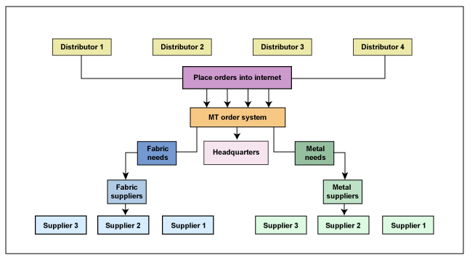

MitiTech decided to minimize the number of employees, secure orders through dealers and distributors, and outsource the manufacture of components. With the potential increase in demand by both GSA users and customers outside the United States—governments all over the world—flexibility was crucial to the company's ability to meet demand as well as to pricing. This business situation rendered the use of estimating CDs obsolete.
To achieve the necessary flexibility, customers had to place orders, with the proper specifications, directly with suppliers. Headquarters had to be aware of both the sales and the requirements given to the suppliers so they could make decisions that would ensure that they could meet customers' needs promptly. To make their operation fast and efficient, management could adjust the sourcing among qualified suppliers and make decisions regarding shipping and installation requirements.
MitiTech did extensive work to ensure that it selected only quality suppliers to be part of its supply chain. It selected suppliers based on their ability to meet MitiTech's high quality requirements and their ability to meet the tight schedules customers demanded, but these suppliers were not exclusively committed to MitiTech. MitiTech's system had to (1) permit switching from one supplier to the next based on the suppliers' ability to perform at the time of the order, and (2) accommodate any new suppliers added in the future.
To enable this process, a new, web-based system replaced the old CD application. The new system permitted rapid price changes because they could be done in real time, for non-GSA customers, rather than requiring the creation and distribution of the older CD technology. The new system ensured that there were no outdated CDs in use that would create confusion and affect customer relations. It also enabled communication of the orders directly to the suppliers, and allowed MT's management to monitor orders and supplier performance.
Based on the standards developed by the Department of Homeland Security (DHS), Safetydrape was certified for protection from flying glass caused by explosions. Once this certification has been granted, neither the company selling the product nor the company using the product can be held liable for casualties resulting from flying glass caused by an explosion. Further, DHS is concerned about the safety of the country's critical infrastructure, refineries, power plants, and chemical plants, to name a few. To help secure these facilities, DHS can provide grants matching up to 50 percent of the cost to companies that install DHS-approved items.
Safetydrape products are manufactured at an ISO 9001:2000-registered quality management system (QMS) plant. The International Organization for Standardization (ISO) is a global network that has identified a series of international quality standards for businesses, governments, and society. "ISO 9001:2000 specifies requirements for a quality management system for any organization that needs to demonstrate its ability to consistently provide product that meets customer and applicable regulatory requirements and aims to enhance customer satisfaction" (International Organization of Standardization, n.d.). Organizations that plan to market their products internationally are required to obtain ISO certification.

The Organizational Model
Recall that we discussed the concept of a general business model earlier in this module, as shown in figure 1.1.
We have discussed the various direct and indirect variables that make up the total environment in which a business works toward its business objectives. Now let's look at competition in some detail, because (1) it affects business strategy, and (2) many of the direct and indirect factors are crucial to determining competitiveness within the business environment. Let's recast the basic business model and examine competition in detail. Begin by taking a look at figure 1.5.
Figure 1.5
General Business Model, Showing
Expanded Competition Variable
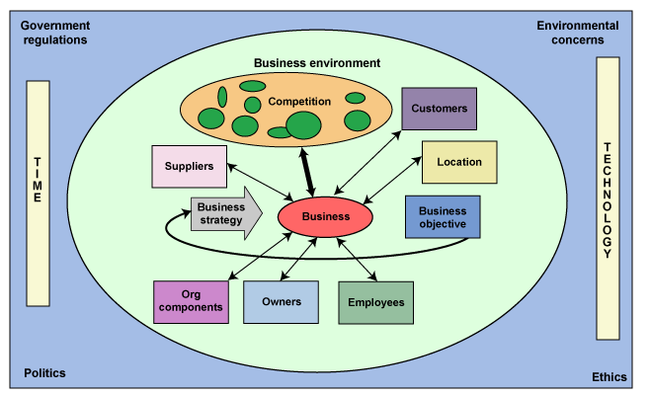

A. The Competitive Environment
In figure 1.6(a), below, we have converted the shape and expanded the competition graphic to indicate that the competitive environment is made up of all the companies that are in the same business. The potential competitors are of all sizes and shapes, and they include both potential and traditional competitors. The different shapes represent businesses that use the same strategy, and all of the businesses in a group compete with one another. Competition between groups can occur; however, it is based on other variables in the environment. Our business is competing with the group that is connected with the arrow.
Figure 1.6(a)
Expanded Competitive Direct Variable
Depicting Potential and Traditional Competitors
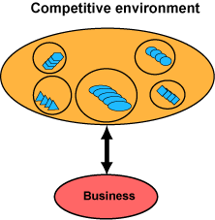
Traditional competitors are shown in figure 1.6(a), above, as the shapes within each circle, and potential competitors are in different circles. See figure 1.6(b), below, for more details.
Figure 1.6(b)
Walmart: Competitive Direct Variable
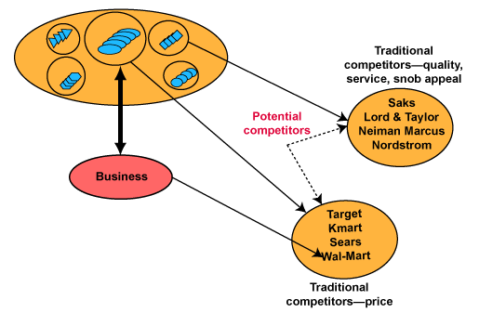
Figure 1.6(b) shows Walmart and its three traditional competitors; they compete on price. Their potential competitors are shown as the quality/service/snob appeal group. The regular, price-conscious Walmart group customer may switch to the other group when shopping for a special occasion or gift, making these two groups potential competitors.
Businesses use many different strategies to compete, and these depend on the industry or product. The first competitive factor that comes to most people's minds is price. Other commonly recognized strategies are customer service, quality and service, delivery speed, payment terms, and location. Some others, which may not be as obvious, are status, snob appeal, reputation, and patents (or special certifications or qualifications). A technology company's competitiveness can be measured by its ability to produce innovative products. For example, think about cell phones and how dramatically they are changing, and realize that about 130 million cell phones are retired each year (Carroll, 2007).
In a December 2, 2006, interview on a WMAL radio (Washington, D.C.) program, Taking Care of Business, Carly Fiorina, the former chief executive officer of Hewlett-Packard (HP), talked about HP's competitiveness and innovation (Roberts, 2006). You can listen to Fiorina's discussion of competition and innovation now (the interview is approximately three minutes long) or read a transcript of the interview.
In figure 1.7, we have made the competitive environment the centerpiece of our business model because it must be the central consideration when developing and adjusting a business strategy. The business strategy serves to guide a business toward its objectives and helps define the importance of all of the other variables in the business model.
Figure 1.7
Competitive Environment:
The Centerpiece of our Business Model
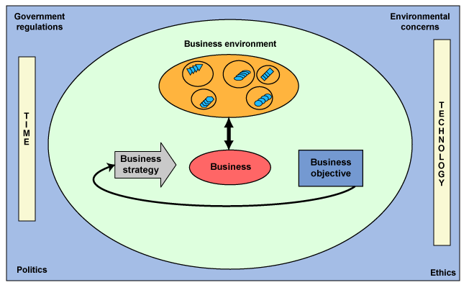

Porter's competitive forces model looks much like figure 1.8, below. We recognize the addition of two of our direct variables—customers and suppliers—and we can also see two new factors—new market entrants and substitute products.
Figure 1.8
Porter's Competitive Forces Model in our Business Model
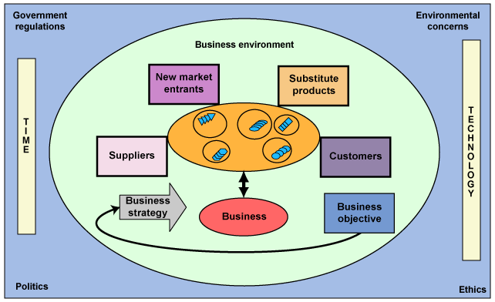

These four factors (customers, suppliers, new market entrants, and substitute products) affect the competitive environment and, to some degree, all of the competitive groups. The impact on each group will vary, however, because of differences in strategy. Companies must be aware of their surroundings. Systems can help in this area by giving management valuable information about some of the competitive model's most important factors. Some of these factors are called leading indicators. Let's listen to the Fiorina interview and see what she has to say on the subject (this portion of the interview is approximately two minutes long), or you can read a transcript of this part of the interview.

1. Substitute Products
Substitute products are new products or services that can make a business's product or service less desirable or even obsolete. This may include existing products or services used in a different way. As mentioned in the Fiorina interview, innovation is the source of substitute products, and substitute products can replace either our own products or a competitor's products. Looking at our integrated model, we can see that both time and technology can be the primary sources of new or obsolete products. For example, cell phones are increasingly replacing traditional landline phones. Other indirect variables can also result in the entry of substitute products. Government regulations, politics, and environmental concerns have brought about a series of substitute products—for example, the increase in alternative, eco-friendly fuel products versus traditional fossil fuels, and hybrid cars versus standard combustion-engine cars.
The use of systems can help a business avoid surprises from its competition by monitoring the indirect factors, government publications, technical journals, supporting research, and other informational sources to identify the potential for new or substitute products.

2. New Market Entrants
Introducing new entrants into a given market affects the total competitive landscape. Because there is only so much money to be spent on a particular good or service, more competition potentially dilutes the profitability of all of the players. To understand the risk presented by new entrants, it is important to understand the barriers that a business must overcome to enter a new market and begin to compete. The higher the barrier is, the less likely it is that new entrants will affect a particular competitive environment.
Barriers can vary, from government regulations to the size of investment required. For example, a company may not be able to compete for government business unless it meets certification requirements; also, competitors holding "talented technology" may prevent another company's entry. For example, entering the automotive industry and producing cars requires a tremendous investment and start-up time. On the other hand, someone opening an ice cream shop on a street corner would not be challenged by large start-up costs. If you wanted to open your own consulting business, little more is needed than a business card.

3. Suppliers
Suppliers affect the competitive environment by setting different prices, quality, service levels, or payment terms for the same item for different customers. The simplest example of this is the retail business, in which supplier factors are related to order size or commitment to the supplier. Walmart can underprice almost everyone because of the size of its demand. This is a good place to point out the idea of competitive groupings. Walmart, Kmart, Target, Sears, and Dollar General are in one competitive group and compete with one another because of size and pricing. They all have systems that support their supplier connections and use them to minimize delivery, inventory, and payment expenses; therefore, one would expect significant system usage for competitive advantage in a retail business of any size.

4. Customers
Customers are the fourth major contributor to the competitive forces model, because it is their money for which everyone is competing. To compete effectively, businesses must select a customer segment that they will focus on attracting—target customers. Once that decision is made, all of the business's efforts must focus on knowing who their customers are, understanding their requirements, meeting their needs, and determining whether they are satisfied. To accomplish this efficiently, systems that develop information about customers, their changing desires and expectations, and their level of satisfaction are critical. Systems that support the processes needed to provide the goods or services must be dynamic and must enable the business to meet the changing expectations of its customers.

Financial Performance Analysis

Money is an asset and the fuel for all businesses, whether for-profit, nonprofit, or government. Proper management of financial assets is vital to achieving the organization's objectives. Management must understand and record the use of assets, including all transactions involving money, so that they can make sound business decisions regarding the use of corporate assets. Businesses first used information systems to replace paper-based methods of helping management perform these functions, and that use continues today.
As we have discussed previously, information technology is a key strategic tool to help support the objectives of a business. Managers must therefore be able to understand the financial model of their organizations so they can make the best decisions regarding investments for their businesses. All organizations have finite resources. The decisions made regarding their optimal use can make the difference between the organization's success and failure in achieving its objectives.
When we begin to analyze businesses, it is important to understand the definition of terms and the impact that various interactions have on a business. This is not meant to serve as an accounting course, but rather as a tool to familiarize you with some vocabulary and concepts used in business. Some terms have been simplified to promote understanding. Let's start with some basic definitions.
Hold your mouse over a term to see examples of it.
assets
fixed assets
liabilities
equity
fixed costs
variable costs
cost structure
revenue
profit
contribution margin
break-even point (BEP)
This may be a review for some of you and new information for others, but it is important that we approach this course with a common understanding of the terms and interrelationships of these concepts so that we can understand why certain management actions make sense and others do not.
Revenue and expenses are the two determinants of profits. Understanding the cost structure of a business can help management emphasize the proper strategy to increase profits. For instance, if a business has high variable costs, then decreasing those costs should be a primary focus of management if they want to increase profits. If a business has high fixed costs, then maximizing the use of those assets should be management's focus.
Because the business model and cost structure are major determinants of business strategy, understanding them is crucial to the development of a systems strategy. Management can also approach profit from the aspect of increasing revenue. Some general areas that could be included in this consideration are customer satisfaction, timeliness of delivery, quality of goods or services, payment terms, and many others. Management's business strategy would define the objectives and areas of concentration, and an information systems strategy could be defined that would support that strategy as well.
It is important to note that this is not an either-or situation, but rather an effort to achieve the maximum benefit so that a business will use a combination of decreasing costs and increasing revenue to maximize profits. If management places too much emphasis on either factor, the result achieved could be negative. Therefore, management must balance the two factors to achieve the best possible result for their business model and financial structure. For example, cost cutting can create dissatisfied customers because the service level drops, thereby decreasing sales, with a corresponding decrease in profits.
It is important to note that revenue is the result of price, which is made up of two factors, with profit constituting roughly 15 to 20 percent and costs making up the remaining 80 to 85 percent. Figure 1.9, below, shows the revenue splits between profit and expenses at two price points: $1 and 80 cents. You can see that for this price reduction—the type Walmart is known for—expenses must be reduced dramatically for the business to remain profitable.
Figure 1.9
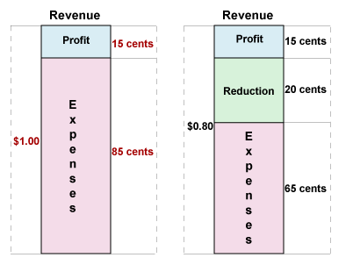
Revenue Split Between Expenses and Profits at Two Price Points
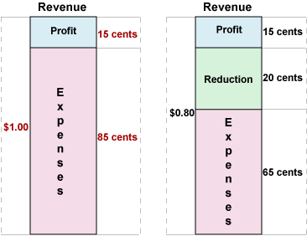
Given that expenses make up such a large percentage of prices, there is more potential to increase profits by decreasing costs than by lowering profit margins. Adjusting any of the variables can have unexpected effects, however, so a good deal of analysis must be done before costs are decreased in an effort to increase profits. The model we will present in the next section will help you understand the interaction of many of these factors.
Below is a link to a model of the Comfy Chair Company that may help you understand the points discussed. The initial model shows a break-even point where the number of chairs sold just covers the expenses and there is zero profit.
Comfy Chair Company model
When using this sensitivity tool, you can change and then leave any of the input fields.
The micro level of the model is designed to analyze the impact on profit at the basic level of a Comfortable Chair as the unit of sale and manufacture. Comfy Chair has a number of fixed costs that the company pays, regardless of the production level. It also has variable costs that vary by the number of units produced; and with a production level of zero, the variable costs will be zero.
The initial situation depicted in the micro level is that the fixed costs are $1,250,000, variable costs are $21/chair, the selling price is $100/chair, and sales are zero. The result is a break-even point of 15,822.78 chairs and a profit of $0. This situation shows that the contribution margin (CM) of $79 per chair has paid all of the fixed costs exactly, and at that point, the profits are $0.
Let's change some of the variables and see what happens. Try the following in the Comfy Chair Company model above. Press the Reset button first. You can change the numbers in the white fields and tab to see the results in the yellow fields. Go ahead and play with it.
- Let's assume that we sell 20,000 Comfortable Chairs at $100 by entering 20,000 in the Enter Units cell (this reflects the number of chairs sold). We see that nothing in the model changes except the profit, which becomes $330,000. Therefore, if we change only the sales number, we can see that profit is strictly related to sales.
- If the insurance company raises insurance costs by $50,300 to $150,000, and we change the insurance cost to the new value ($150,000) in our model, we see that a couple of things change. The BEP increases to 16,459 units and the profit decreases to $279,700, which reflects the $50,300 increase in insurance because we assumed no change in the sales volume.

What we have been demonstrating is that when any business decision is made, it can have many effects—some desirable and some not so desirable. It is important to note that profits can be affected by many factors and that the business model and financial structure have a major effect on the decisions that management makes.
Let's experiment with a different structure like Booz Allen Hamilton (BAH), where the fixed costs are low and the variable costs are high.
Booz Allen Hamilton model
In this type of structure, it is very difficult to decrease variable costs by increasing capital spending or fixed assets, because the product being sold is staff hours, or the knowledge of that staff.
You can see in the BAH model that the fixed costs and contribution margin at BAH are significantly lower than at Comfy Chair.
Let's change some of the variables and see what happens. Try the following in the Booz Allen Hamilton model above. Press the Reset button first. You can change the numbers in the white fields and tab to see the results in the yellow fields. Go ahead and play with it.
- Let's assume that BAH consults for a total 20,000 hours at $150 per hour by entering 20,000 in the hours-sold cell. We see that nothing in the model changes except the profit, which becomes $677,300. Therefore, if we change only the sales number, we can see that profit is strictly related to sales.
- If the insurance company raises insurance costs by $50,300 to $150,000, and we change the insurance cost to the new value ($150,000) in our model, we see that a couple of things change. The BEP increases to 9,550 hours, and the profit decreases to $627,000, a decline that is exactly the same as the increase in insurance because we assumed no change in the sales volume. This is the same result we saw in the Comfy Chair Company example because the contribution margin cannot go to profits until the new fixed cost is paid.

This provides a vivid example of how the financial structure of a company and the nature of the competitive environment can affect management decisions and, therefore, systems and investment strategies.
What we have been doing in the past few exercises and examples is called a sensitivity analysis or a what-if analysis, which is used constantly in business and in many personal situations to look at the financial results of potential actions. It is a very powerful tool and could also be called a decision-support system. A model is created that reflects the reality of the situation or business, and then variables are adjusted to determine the results. Try the indicated exercises in the rest of this section, and when you are satisfied with your answers, check to see if they are correct.
If we look at MitiTech, we see that it is a very low-fixed-cost company that has low variable costs and low overhead. Also, its fixed costs are stable because it uses outsourcing.
MitiTech model
MitiTech is not penalized during slack times, has no high fixed costs to pay, and does not have to purchase equipment to increase capacity; they merely increase the workload on their suppliers. (Note: The numbers used in this example for MitiTech are purely hypothetical and are based only on their organizational structure.)
Let's change some of the variables and see what happens. Try the following in the Mitigation Technologies model above. Press the Reset button first. You can change the numbers in the white fields and tab to see the results in the yellow fields. Go ahead and play with it.
- Let's assume that we sell 20,000 units at $200 by entering 20,000 in the units-sold cell. We see that nothing in the model changes except the profit, which becomes $2,725,000. So if we change only the sales number, we can see that profit is strictly related to sales, as the BEP stays the same: 1,587 units.
- If the insurance company raises insurance costs by $50,000 to $100,000, and we change the insurance cost to the new value ($100,000) in our model, we see that a couple of things change. The BEP increases to 1925.68 units, and the profit decreases to $2,675,000, which is exactly the increase in insurance cost because we assumed no change in the sales volume. These first two examples produce the same results in all three cases.
- The sales department tells management that they can increase revenue by 20 percent by increasing sales 20 percent, or 4,000 to 24,000 units, but the production department says that to achieve that number of units, they will have to add another supplier of the parts and pieces. (No new piece of equipment will be required, as in the previous instances, because the manufacturing is outsourced.) What happens when we enter those changes into our model? Clearly, a 20 percent increase in sales will increase revenue by 20 percent, or to $4,800,000, but what happens to profits?
There are no changes in the model other than changing sales to 24,000 units. The result is that the BEP does not change, because there is no increase in fixed costs, and profits increase to $3,267,000, an increase of 22 percent (($3,267,000 - $2,675,000) ÷ $2,675,000) ~ 22%). This indicates that profits would increase 22 percent without the risk of any investment, which is a benefit of outsourcing.
- Management believes that they can increase the price per unit by 10 percent in this new situation and improve profits by 10 percent, but price is not the nature of MitiTech's competitive environment. The competition is based on the results of the product, its patent, and the DHS certification, so the sales volume will remain the same (unlike the other situation at Comfy Chair). Using our model, what will happen to profits if only the price is increased by 10 percent?
If we increase the price to $220/unit, profits will be $3,747,000, an increase of $480,000, or 15 percent. So the change in price of 10 percent results in an increase in profits of 15 percent and a decrease in the BEP to 1,696 units, because no costs were changed and the contribution margin increased, lowering the BEP and starting profits earlier.
- The chief information officer recommends that a new computer and software costing $100,000 be purchased and installed because it will decrease staff costs by $4/unit and shipping and handling by $2/unit, resulting in a 10 percent increase in profits. Is he correct?
When you try the numbers in the model, you will see that the addition of computer resources would have no effect on either staff costs or shipping and handling, because they are not part of the variable costs. Instead, this purchase would increase fixed costs. This investment should not be made, based solely on these facts.
This demonstrates both the power of outsourcing and the importance of the business model, financial structure, and competitive environment in the determination of a company's business and systems strategies.
We have seen three different, but representative, business models, financial structures, and competitive environments, and how management decisions and business strategies are tied to these factors. These illustrations also indicate that understanding these factors about a company is critical to understanding where the real value of systems technology is to a business. Although the businesses used in these models are all for-profit businesses, the same types of modeling and variables exist in nonprofits and government. A government is not a homogeneous entity; it is composed of a number of different government agencies. These agencies do not have identical models, but they are made up of some or all of the above examples.

The Value Chain Concept
At this point, we want to address the value chain of organizations. The value chain of any organization describes the business activities that the company does to add worth or importance, and thereby profits. A question often asked in procurement departments when analyzing a bid from a company is, "How do they make their money?" What they are really asking is, "What is their value chain?"
Value Chain—Did You Know?
As we saw with the elements of the financial models in the previous discussion, changes in one activity (for example, sales) have a ripple effect in other areas (such as production). To fully understand how information systems can be a critical and effective tool to support business strategy, you should understand how the various activities in an organization add value. Then decisions related to the information needed and how it is made available using technology can be analyzed in terms of how those systems best add value to the business activities. Figure 1.10, below, identifies major areas in the value chain.
Figure 1.10
Detailed Value Chain
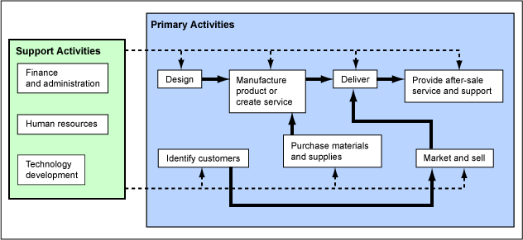
Source: Adapted from Schneider (2002, p. 23)
For the purposes of this discussion, we will focus on the primary activities. As we saw previously in the business model section, however, the support activities can be significant components of an organization's value chain. For example, because Booz Allen Hamilton's main corporate assets are the knowledge and skills of its employees, effective recruiting and retention activities are critical to its success.

A. Supply Chain Management
At the basic level, a system consists of three major activities: input, process, and output. Although the components in these three areas differ widely from one organization to the next, the fundamentals are the same. Therefore, when we discuss supply chain management, we must first define the supply chain. You can think of this in terms of these questions:
- What are the inputs?
- What kind of processing is required?
- What are the outputs, and how are they delivered to the customer/end user?
The supply chain represents "the network of organizations and business processes for procuring raw materials, transforming these materials into intermediate and finished products, and distributing the finished products to customers" (Laudon & Laudon, 2006, p. 360). What constitutes materials and products also varies widely. At Walmart, the number of products is huge. In a professional-services firm like Booz Allen Hamilton, the products are less tangible—the information, advice, and recommendations that the consultants provide to their clients are the products (Laudon & Laudon, p. 92).
Below is a simple representation of a supply chain that shows a second-tier supplier (a supplier to a supplier). This is a supplier to a firm who performs a process and sells to a wholesaler, who sells to a retailer and then to the ultimate customer. Think about this model as representing an automobile manufacturer, such as Ford Motor Company (which would have many more tiers of suppliers than what is shown here). This model could also represent the supply chain for Walmart.
Hold your mouse over each item in figure 1.11 to see an example of a type of organization associated with that step.
Figure 1.11
Basic Supply Chain Model
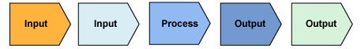
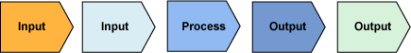

Figure 1.12
Supply Chain with Activities Model
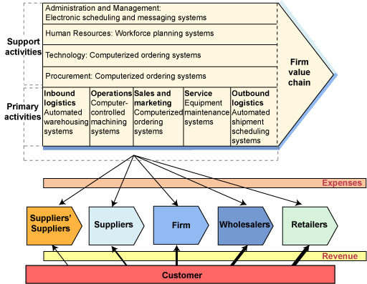
Figure 1.12, above, represents the supply chain with activities. These activities occur to some extent in any firm that participates in the supply chain and uses the systems associated with the various activities. It is important to note that the same general corporate structure is present with each participant in the value chain, regardless of its business model or financial structure. The various activities and their related systems are the areas in which the companies incur expenses. The amount of expense and the importance of the different areas would be defined by the company's business model.
For simplicity, we have represented these expenses with arrows of the same width, but realistically, arrows of varying thicknesses would represent these amounts, just as they did in figure 1.3, the Booz Allen Hamilton business model. The width of the revenue arrow increases with each step toward the ultimate customer, indicating that the revenue received in each step of the value chain increases as we get closer to the ultimate customer. This increase in revenue at each step represents the value added by that participant in the chain.
A shorter supply chain (one that contains fewer components) is less complex and easier to manage. For example, Booz Allen Hamilton's value chain shows a greater emphasis on the traditional support activities and has a much shorter supply chain that we can infer from the BAH business model.
As illustrated below in figure 1.13, BAH is both the beginning and the end of its supply chain, a situation that results in its experiencing all of the expenses and receiving all of the revenues.
Figure 1.13
Booz Allen Hamilton Supply Chain
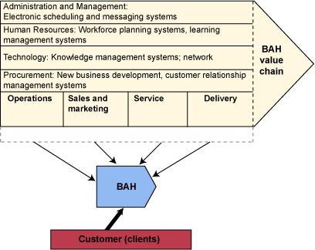
Looking at Mitigation Technologies, we see a more traditional company in terms of building and selling a specific product. Supply chain management involves the organization's methods of effectively and efficiently acquiring the needed materials, turning the materials into finished goods, and getting those goods into customers' hands.
As shown in the financial models, organizations have alternatives in terms of how they seek to increase profits. When Comfy Chair sought to increase sales by 20 percent, the production department required additional equipment to meet the demand. This is a supply chain management issue. Because production had the right information and tools required to perform the needed analysis, they could predict the impact of a 20 percent increase in sales volume and determine what it would take to meet that increased demand.
If you look back at the business models illustrated at the beginning of this module, you will see that the width of the arrows reflect the degree to which an element may affect (or be affected by) the business. In discussing supply chain management, the focus is on the arrows related to suppliers and customers. In an organization with a very thick supplier arrow, a substantial portion of the operating-expense budget relates to that aspect of the supply chain. Most of these expenses are variable costs, so as we have seen, a reduction of these costs can increase profits significantly. Because we know that organizations have finite resources and should seek to optimize their use of those resources, it is evident that management can provide value and profitability by focusing on the myriad activities in this area.
Optimal management of the supply chain can help an organization minimize costs. For example, maintaining large volumes of inventory costs money because the inventory requires space, personnel, and tracking; it can be lost or stolen, or it can become worthless as a result of obsolescence or shelf-life expiration. In addition, suppliers and vendors expect to be paid when they provide the materials and will not want to wait for them to be shipped and sold. The company cannot receive payment for inventory until it is actually sold to customers—a reality that can seriously affect a business's financial well-being. But let's not forget that the customers will expect to receive their purchases in a timely manner and will have little tolerance for long delivery times because the product is not available. Proper supply chain management and systems must seek to balance these requirements.
Organizations can minimize the time from initial procurement to customer delivery (cycle time) through good planning (forecasting demand, production schedules, delivery routes, and so on), thereby increasing value while using the minimum amount of resources. The availability of accurate information to the right people at the right time is critical to accomplishing this.
The supply chain is the network that connects the elements from outside the organization, linking the business to its vendors and customers. For example, a retail store will include its suppliers of shoes and accessories in its network. A manufacturing company will include its shipping agents (such as FedEx and UPS) in its supply chain. An online business network includes customers, vendors, and delivery services connected via the Internet. An online retailer may include its brick-and-mortar stores to simplify the return of merchandise for its customers.
In the general business model, we indicated that a variety of factors affect a business's strategy. To respond to competitive challenges, environmental changes, or supplier issues, an organization must react quickly to maintain or improve its position. This may call for adding new or substitute products and services, lowering costs, increasing quality, or changing delivery methods. Because of the many activities involved in the supply chain, each of which has a number of related tasks, the use of information technology and effective information systems is critical to a rapid response and well-executed changes in strategy.
Although the logic of paying attention to the supply chain is evident, the specific business value and return on investment may not be as obvious to management. A study led by researchers from Stanford University identified the link between the supply chain and financial performance by studying 630 global companies and evaluating their supply chain performance. The researchers looked for companies that excelled at managing inventory, costs of goods sold, and return on assets. This study provided four key findings regarding leading companies in this area (D'Avanzo, von Lewinski, & Van Wassenhove, 2003):
- Senior executives recognize supply chains as critical drivers that can make large contributions to profit and add shareholder value and competitive distinction.
- The companies in the study integrate supply chains into their key business strategies and put considerable effort into developing integrated operational models.
- Innovation is built into these operating models, with emphasis on outsourcing, integrating internal sources with external ones, and ensuring that market demands match supply.
- The companies in the study are rigorous in executing their strategy, constantly adapting it to changing market needs.
This study demonstrated that supply chain management is not just a business function, but a set of key business processes that successful executives recognize as being a critical strategic driver. The supply chain must be constantly monitored and improved, using innovative technologies and processes, to support the organization's success.
 | Think About It 1.1: Walmart's Supply Chain  Walmart has a goal of always giving its customers the lowest price. It achieves this pricing strategy by excelling at the management of its supply chain. Walmart uses more than 60,000 suppliers to provide merchandise to its stores around the world. Because of very small profit margins, it is critical that the supply chain be as efficient and cost-effective as possible. Walmart provides prospective suppliers with extensive information about its process and requirements on its website. This includes electronic data interchange (EDI) capabilities, timely delivery, and quality assurance measures. Walmart has standardized its supply chain management process and works with vendors to help them comply with these requirements for mutual benefit.
Now let's return to Mitigation Technologies, so we can analyze its supply chain and how it supports its business strategy.

B. Mitigation Technologies Supply Chain
A key business strategy of Mitigation Technologies is to stay "lean and mean." In other words, rather than building a large manufacturing and production facility, MitiTech has chosen to identify and qualify a number of vendors who can provide the various customized components needed to produce Safetydrape. So let's consider what may be key requirements in monitoring its supply chain. For example, getting accurate information to the vendors, tracking orders, monitoring delivery schedules, and monitoring quality assurance are key activities.
Because Safetydrape is manufactured specifically for each customer (in terms of window sizes and installation requirements), maintaining an inventory of completed products is impractical. However, there are component parts (such as fasteners, brackets, material, and metal) that are stockpiled by the vendors who create the custom components. MitiTech does have a very small warehouse facility to permit consolidation of small orders, and the company uses shipping specialists to consolidate and deliver large domestic or export orders.
The distribution channels for Safetydrape are expanding, and MitiTech expects sales to increase dramatically in the coming years. As a small company with a unique product, MitiTech must ensure that its supply chain can handle future demand. A key success factor for MitiTech thus far has been its reputation as a provider of quality products and services.
Let's look at the supply chain for MitiTech, shown in figure 1.14. Here we will evaluate MitiTech's supply chain by focusing on the primary activities—those that provide value to the customer related to production and distribution of its goods.
Figure 1.14
MitiTech Supply Chain Model
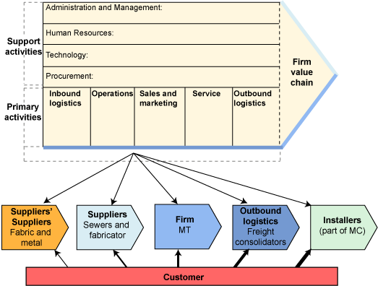
Now that we have defined the supply chain for MitiTech, it is your turn to think about the systems that support these activities. Given its business model, the systems are fairly simple.
 | Try This 1.1: MitiTech's Value Chain Systems

Introductions

Previous
Next


Welcome to our class!
Before the end of Week 1, you need to create an Introductions post about yourself AND reply to two (2) other student's threads before the end of Week 1. Click on their name and reply to what they have posted.
You can enter your post in this Discussion Conference by clicking on the conference title 'Introductions [Required]' (in blue above).
Then use the [Start a New Thread] button and enter your name as the thread title (see my example) and then please tell us:
- Who you are (what you like to be called, if it is different from your UMUC username)?
- What are some interesting things about you?
- What kind of computers do you use include OS and Office Suite versions?
- What is your major field of study?
- What do you hope to gain from this class and why did you enroll?
An important part of your introduction is for each of you to identify that information system are important to whatever major you are studying. I recognize that IFSM 300 Information Systems in Organizations is a required course for many majors and there is a good reason for that. Recognizing how information systems contribute to your field will help reinforce the value of this course.
For example, if my major was archeology (purposely picking a major UMUC does not offer), I could include how geographical information systems (GIS) are a key tool for archeologists to help with surveying and modeling excavation sites. In addition, GIS can enable storing tremendous amounts of data and offer the ability to “slice and dice” the data in various ways and combine different sets of data for further analysis to support research and presentation of information.
I look forward to getting to know each of you and working with you this semester.

Ask Your Professor
Discussion Topic
 | If you have any questions about any aspect of this class, please post them in this discussion area so that everyone can see my response.
If you have a question about something, it is very likely that others have the same question. No question is a foolish one; each of us needs things explained in different ways, and part of my job is to be sure you thoroughly understand the course material and assignments. So, do not hesitate to ask!
If you have something of a more personal nature, or if you want to ask about your own work, please email or page me using the LEO Messaging System (envelope icon on top bar) to send me a note and I will be happy to respond.

